**Milestone 3**

1.

Before the third milestone, and I successfully tested the functionality of my web application. The database was successfully connected to PHP and the server started as PHP based xampp such a mongodb Server to work and fetch files from the database. This database has been successfully imported to display information on football web pages. Queries are made to the database to provide and display the results of these queries on the screen. The database of matches of the English Premier League was also used in which there is a huge amount of statistics as well as information on past matches for the previous season. Details of the database structure, as well as screenshots of the use of the proposed below. 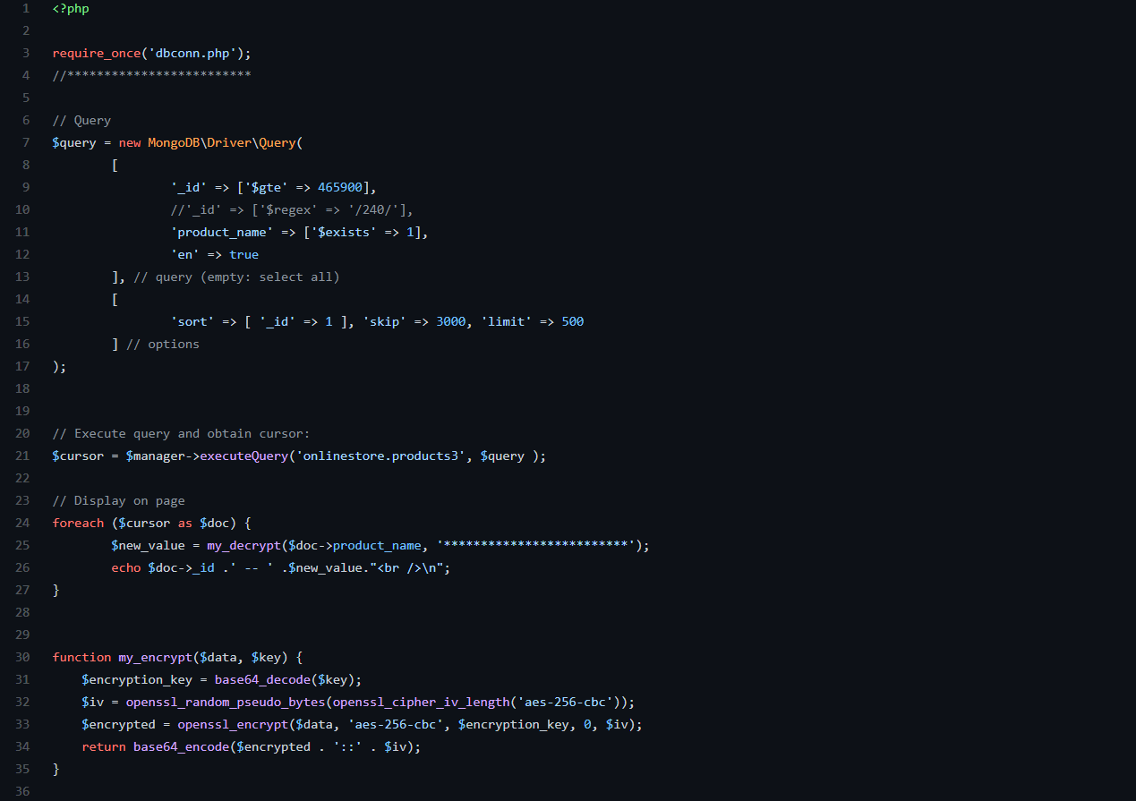

**Php code**

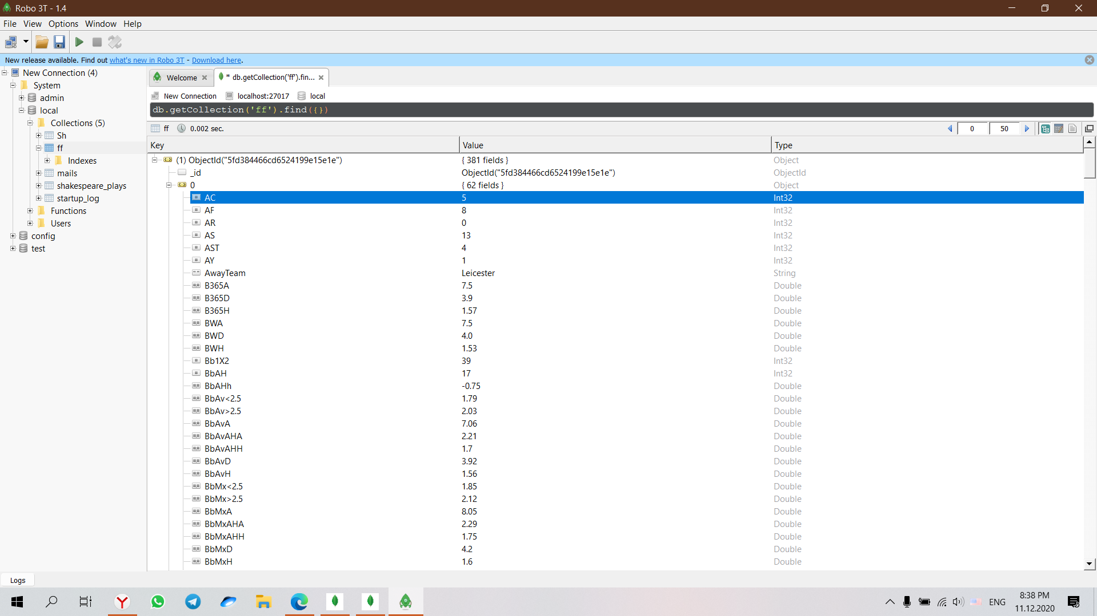

**Database structure**



**Main predictive parameters**

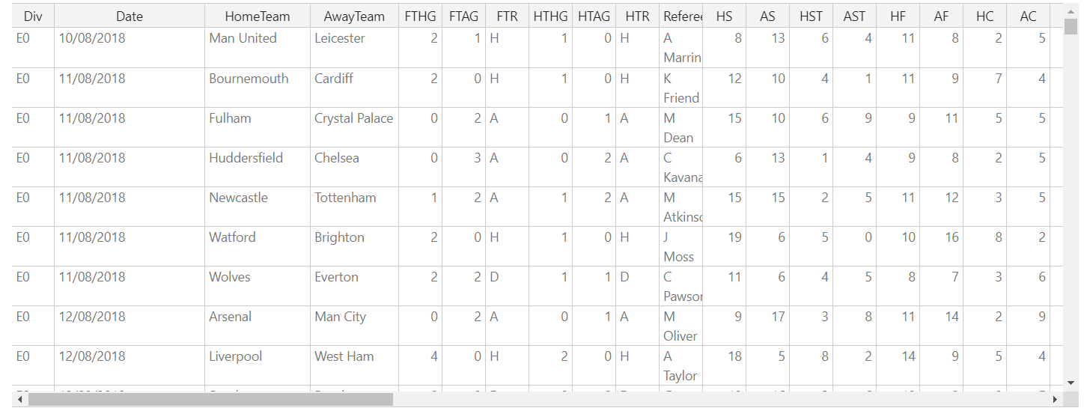

**Table view of database**

**2.**

**Field information:**

Field Name Order Type (Format) Description

Div 1 string (default)

Date 2 string (default)

HomeTeam 3 string (default)

AwayTeam 4 string (default)

FTHG 5 integer (default)

FTAG 6 integer (default)

FTR 7 string (default)

HTHG 8 integer (default)

HTAG 9 integer (default)

HTR 10 string (default)

Referee 11 string (default)

HS 12 integer (default)

AS 13 integer (default)

HST 14 integer (default)

AST 15 integer (default)

HF 16 integer (default)

AF 17 integer (default)

HC 18 integer (default)

AC 19 integer (default)

HY 20 integer (default)

AY 21 integer (default)

HR 22 integer (default)

AR 23 integer (default)

B365H 24 number (default)

B365D 25 number (default)

B365A 26 number (default)

BWH 27 number (default)

BWD 28 number (default)

BWA 29 number (default)

IWH 30 number (default)

IWD 31 number (default)

IWA 32 number (default)

PSH 33 number (default)

PSD 34 number (default)

PSA 35 number (default)

WHH 36 number (default)

WHD 37 number (default)

WHA 38 number (default)

VCH 39 number (default)

VCD 40 number (default)

VCA 41 number (default)

Bb1X2 42 integer (default)

BbMxH 43 number (default)

BbAvH 44 number (default)

BbMxD 45 number (default)

BbAvD 46 number (default)

BbMxA 47 number (default)

BbAvA 48 number (default)

BbOU 49 integer (default)

BbMx>2.5 50 number (default)

BbAv>2.5 51 number (default)

BbMx<2.5 52 number (default)

BbAv<2.5 53 number (default)

BbAH 54 integer (default)

BbAHh 55 number (default)

BbMxAHH 56 number (default)

BbAvAHH 57 number (default)

BbMxAHA 58 number (default)

BbAvAHA 59 number (default)

PSCH 60 number (default)

PSCD 61 number (default)

PSCA 62 number (default)

3. Summary and conclusion

Conclusion to create this project, we used the backend PHP development language using front-end development such as HTML CSS JavaScript and various add-ons in the form of bootstrap. Also, my application uses cool elements such as adding, deleting, updating and changing data, which gives great functionality and the ability to interact with the database.  
the result is a software project that is used by all Modern technologies to meet the needs of users all the tasks have been successfully completed; these developments meet the highest quality standards and are well documented and show good stability in work on.

4. Referenses

<https://github.com/MinakovNV>

<https://www.mongodb.com/>

<https://www.php.net/>